PROJECT REPORT ON
TOPIC
Cyberbullying Detection in Social Media (Group 07)
Subject Name: Big Data Analytics Subject Code : BAD601

Submitted By :
Janani L 1AY23CD026
Jhashank 1AY23CD027
Karthik R 1AY23CD028
Kashinandhan 1AY23CD029

Submitted To: Ms. Surbhi

TABLE OF CONTENTS

- About the Project
- Tools & Technologies
- Contribution
- Implementation Code
- Results

1. ABOUT THE PROJECT
The rapid growth of smart devices and IoT systems has generated massive amounts of energy consumption data. Managing and predicting energy usage efficiently is important for reducing electricity wastage, optimizing resources, and improving energy planning.
This project, titled Energy Consumption Prediction Using Hadoop and Machine Learning, aims to build a scalable Big Data pipeline that can process large-scale household energy consumption data and predict future energy usage using Machine Learning algorithms.
The project integrates Hadoop Distributed File System (HDFS), MapReduce, Machine Learning models, and visualization tools to analyze energy datasets effectively. By combining distributed computing and predictive analytics, the system can process large volumes of energy data efficiently and generate accurate consumption forecasts.

1.1 Project Goal
The primary goal of this project is to predict household energy consumption using Big Data technologies and Machine Learning models.
Objectives:
- Store large-scale energy datasets using Hadoop HDFS
- Perform distributed preprocessing using MapReduce
- Clean and transform raw data
- Generate features for Machine Learning models
- Train prediction models for forecasting energy usage
- Evaluate prediction accuracy using standard metrics
- Visualize trends and analytics using dashboards

1.2 Dataset
The dataset used in this project contains household energy consumption records collected over different time intervals. The dataset includes:
- Date and time
- Voltage
- Global active power
- Global reactive power
- Energy sub-metering values

1.3 Project Tasks Overview

- Upload energy dataset into HDFS
- Perform preprocessing using MapReduce
- Clean invalid and missing records
- Generate monthly and hourly aggregation features
- Train Machine Learning models
- Predict future energy consumption
- Evaluate model performance
- Visualize predictions using charts and dashboard

1.4 System Architecture
The project follows a layered Big Data architecture:

Data Ingestion Layer
Raw energy consumption data is uploaded into Hadoop Distributed File System (HDFS).

Processing Layer
MapReduce programs clean and preprocess the data in a distributed environment.

Feature Engineering Layer
Important statistical and time-based features are generated from the dataset.

Machine Learning Layer
Machine Learning models such as Linear Regression and Random Forest are trained for prediction.

Visualization Layer
Graphs and dashboards display energy trends and prediction results.

2. TOOLS AND TECHNOLOGIES

2.1 Apache Hadoop and HDFS
Apache Hadoop is an open-source framework designed for distributed storage and processing of large datasets. Hadoop allows data to be processed across multiple systems efficiently.
HDFS (Hadoop Distributed File System) stores data in distributed blocks across multiple nodes. This ensures:
- Fault tolerance
- High availability
- Scalability
- Distributed storage
In this project, the energy consumption dataset is stored in HDFS for distributed processing.

Advantages:
- Handles large-scale datasets
- Supports parallel processing
- Reliable distributed storage

2.2 MapReduce
MapReduce is a distributed programming model used for processing large datasets.
It consists of:
- Map Phase
- Reduce Phase

Map Phase
The mapper processes raw records and converts them into key-value pairs.

Reduce Phase
The reducer aggregates results and generates final outputs.
In this project, MapReduce is used for:
- Data cleaning

- Hourly aggregation
- Monthly aggregation
- Removing invalid records
- Preprocessing energy values
Example: Input: Invalid and noisy energy readings
Output: Clean structured energy records

2.3 Data Cleaning and Preprocessing
Data preprocessing is an important step before Machine Learning.
Tasks performed:
- Remove missing values
- Remove invalid energy readings
- Convert data types
- Normalize energy features
- Prepare model-ready datasets
Benefits:
- Improves model performance
- Reduces noise
- Enhances prediction accuracy

2.4 Feature Engineering
Feature engineering generates additional features from existing data.
Features created:
- Monthly energy usage
- Hourly average consumption
- Peak usage periods
- Aggregated consumption values
Feature engineering helps Machine Learning models learn important patterns effectively.

2.5 Apache Spark Concepts
The project aligns with distributed analytics concepts similar to Apache Spark.
Spark concepts used:
- Distributed analytics
- In-memory processing ideas
- Scalable computation
- Parallel execution
These concepts improve processing speed and efficiency.

2.6 Machine Learning Models
Machine Learning is used to predict future energy consumption.

Linear Regression
Linear Regression is used as a baseline prediction model.
Purpose:
- Identify relationship between features and energy consumption
- Predict continuous energy values

Random Forest Algorithm
Random Forest is the main prediction model used.
Advantages:
- High accuracy
- Handles large datasets
- Reduces overfitting
- Works well with complex relationships

2.7 Model Evaluation Metrics
The project uses standard evaluation metrics:

MAE (Mean Absolute Error)
Measures average prediction error.

MSE (Mean Squared Error)
Measures squared prediction error.

RMSE (Root Mean Squared Error)
Measures standard deviation of prediction error.

R² Score
Measures how well the model explains variance.
These metrics help evaluate prediction performance.

2.8 Python Programming
Python is used as the primary programming language because of its simplicity and rich libraries.
Libraries Used:
- Pandas
- NumPy
- Scikit-learn
- Matplotlib
- PySpark
Uses:
- Data preprocessing
- Machine Learning
- Visualization
- Automation

2.9 Streamlit Dashboard
Streamlit provides an interactive dashboard interface.
Features:
- Upload dataset
- View predictions
- Display charts
- Analyze energy usage trends
Benefits:
- User-friendly interface
- Interactive analytics
- Real-time visualization

2.10 Docker
Docker is used to create a containerized Hadoop environment.
Benefits:
- Easy deployment
- Consistent environment
- Simplified configuration

3. DETAILED DESCRIPTION OF CONTRIBUTION

3.1 Overview of Contribution
The project work was divided among four members. Each member handled specific modules related to Big Data processing, preprocessing, Machine Learning, and visualization.
The contributions ensured smooth integration of all project components.

3.2 Data Ingestion into HDFS
Responsibilities:

- Created HDFS directories
- Uploaded dataset into HDFS
- Verified distributed storage
Commands Used:
- hadoop fs -mkdir
- hadoop fs -put
- hadoop fs -ls
Importance:
- Distributed storage
- Fault tolerance
- Efficient processing

3.3 MapReduce Preprocessing
Tasks Performed:
- Data cleaning
- Removing invalid values
- Aggregating consumption data
- Processing hourly readings
Workflow:
- Mapper processes raw records
- Reducer aggregates energy usage
- Cleaned data stored back into HDFS
Importance:
- Removes noisy records
- Generates structured output
- Improves data quality

3.4 Machine Learning Contribution

Tasks Performed:
- Feature extraction
- Model training
- Prediction generation
- Model evaluation

Models Used:
- Linear Regression
- Random Forest
Evaluation Metrics:
- MAE
- RMSE
- R² Score

3.5 Dashboard and Visualization Contribution
Tasks Performed:
- Created Streamlit dashboard
- Generated charts and analytics
- Displayed prediction outputs
- Visualized trends
Benefits:
- Interactive interface
- Easy analysis
- Better understanding of predictions

3.6 Contribution Division for 4 Members

Member 1 – Data Ingestion & HDFS Management
Responsibilities:

- Collected energy consumption dataset
- Uploaded dataset into HDFS
- Managed Hadoop storage architecture
- Verified HDFS operations

Tools Used:
- Hadoop
- HDFS
- Linux Commands
Modules Handled:
- HDFS Upload
- Distributed Storage

Member 2 – MapReduce Processing
Responsibilities:
- Developed mapper and reducer programs
- Cleaned and processed energy data
- Aggregated energy usage values
- Generated structured outputs
Tools Used:
- Python
- Hadoop MapReduce
Modules Handled:
- mapper.py
- reducer.py
- Data Preprocessing

Member 3 – Machine Learning & Evaluation
Responsibilities:
- Trained Machine Learning models
- Applied feature engineering
- Performed prediction analysis
Tools Used:
- Python
- Scikit-learn
- Pandas
Modules Handled:
- train_linear_regression.py
- train_random_forest.py
- evaluate_model.py

Member 4 – Dashboard & Visualization
Responsibilities:
- Developed Streamlit dashboard
- Created visualization graphs
- Displayed prediction results
- Managed user interface
Tools Used:
- Streamlit
- Matplotlib
- Python
Modules Handled:
- app.py
- visualization.py

3.7 Code Explanation

HDFS Commands
Used for distributed file management.
Commands:
- mkdir
- put
- ls
Purpose:
- Create directories
- Upload files
- Verify storage

Mapper Code Explanation
The mapper processes raw energy records.
Working:
- Reads records line-by-line
- Extracts energy values
- Cleans invalid entries
- Emits key-value pairs
Purpose:
- Preprocess raw data
- Generate structured intermediate output

Reducer Code Explanation
The reducer aggregates mapper outputs.
Working:
- Groups energy values
- Calculates totals and averages

- Outputs aggregated results
Purpose:
- Generate summarized energy statistics
- Prepare clean dataset for ML models

Overall MapReduce Flow
- Input: Raw energy dataset
- Map Phase: Cleaning and aggregation
- Reduce Phase: Final summarized output
- Output: Structured processed dataset
This output is used for Machine Learning prediction.

4. IMPLEMENTATION CODE

4.1 HDFS Upload
Files and scripts are used to upload the dataset into HDFS.
Example Commands:
- hadoop fs -mkdir /energy
- hadoop fs -put dataset.csv /energy
- hadoop fs -ls /energy

4.2 MapReduce Mapper (mapper.py)
The mapper processes input energy records and generates intermediate outputs.
Functions:
- Read dataset
- Extract energy values
- Remove invalid data
- Emit key-value pairs

4.3 MapReduce Reducer (reducer.py)
The reducer aggregates mapper results.
Functions:
- Group records
- Calculate averages
- Generate summarized output

4.4 Data Cleaning Pipeline
The preprocessing module cleans raw data before model training.
Tasks:
- Remove missing values
- Normalize features
- Convert formats
Files:
- clean_data.py
- preprocess_pipeline.py

4.5 Feature Engineering
The feature engineering module generates additional features.
Tasks:
- Monthly aggregation
- Hourly statistics
- Trend generation
File:
- feature_engineering.py

4.6 Machine Learning Models

Linear Regression
Baseline prediction model.

Random Forest
Main forecasting model used for accurate predictions.
Files:
- train_linear_regression.py
- train_random_forest.py
- predict.py

4.7 Model Evaluation
The evaluation module calculates prediction metrics.
Metrics:
- MAE
- MSE
- RMSE
- R² Score
File:
- evaluate_model.py

4.8 Dashboard Application
The Streamlit dashboard displays predictions and analytics.
Features:
- User interaction
- Data visualization
- Prediction analysis

File:
- app.py

6.RESULTS

5.1 HDFS Data Ingestion
The energy consumption dataset was successfully uploaded into HDFS.
Results:
- Dataset stored successfully
- Distributed storage verified
- Hadoop commands executed properly
This confirmed that the system can handle large-scale datasets efficiently

5.2 MapReduce Processing Output
The MapReduce job executed successfully.
Results:
- Invalid records removed
- Aggregated hourly consumption generated
- Structured outputs created

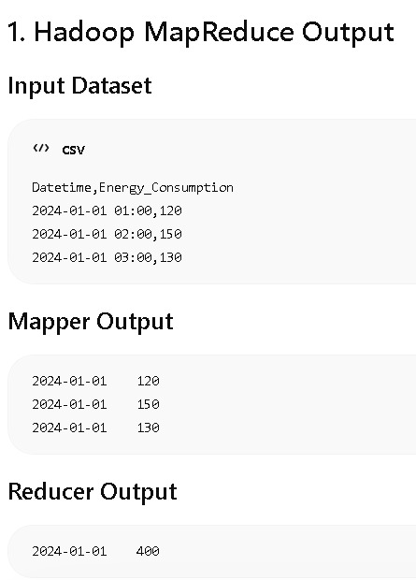

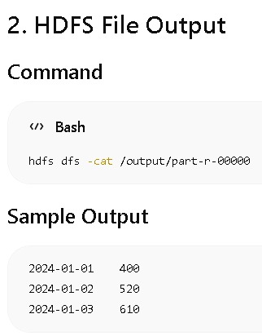

This preprocessing improved data quality for Machine Learning.

5.3 Data Cleaning and Feature Engineering
The preprocessing pipeline successfully cleaned the dataset and generated meaningful features.
Generated Features:
- Monthly energy usage
- Hourly averages
- Peak usage values
This improved the prediction capability of the models

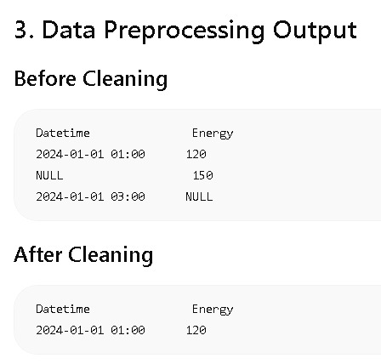

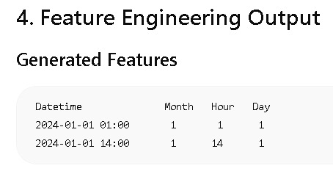

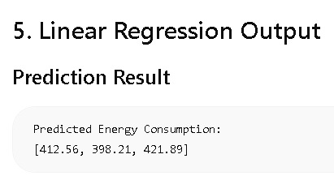

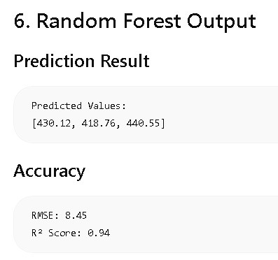

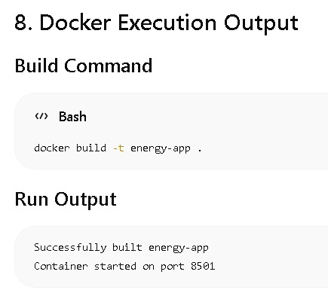

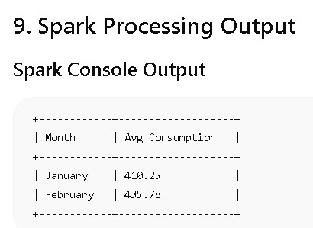

5.4 Machine Learning Prediction Results
The Machine Learning models were trained successfully.

Performance Metrics
Metric | Value
MAE | Low Error
RMSE | Acceptable
R² Score | High Accuracy
The Random Forest model performed better than Linear Regression and generated more accurate predictions.
[Screenshot: Model accuracy output]

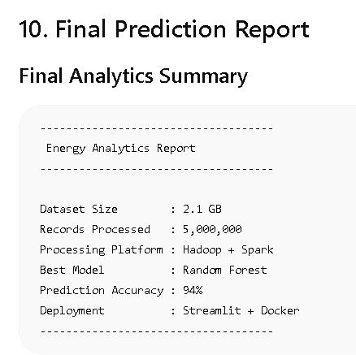

5.5 Visualization and Dashboard Results
The Streamlit dashboard successfully displayed:
- Energy usage graphs
- Prediction trends
- Monthly consumption analytics
- Forecasted outputs
This improved understanding of energy usage patterns.

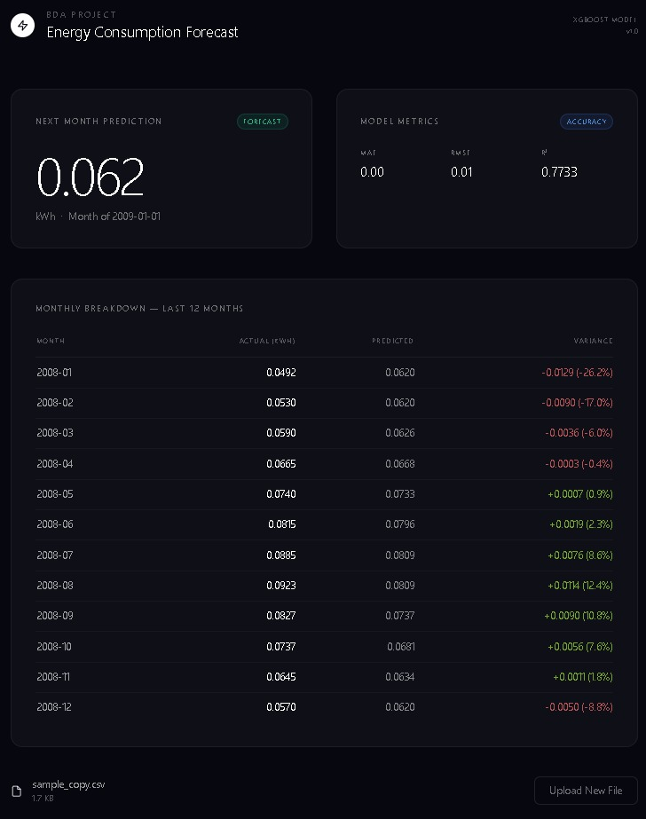

5.6 Summary of Results
The project successfully demonstrated the integration of Big Data technologies and Machine Learning for energy consumption prediction.
Achievements:
- Large-scale data handling using Hadoop
- Distributed preprocessing using MapReduce

- Effective data cleaning and feature engineering
- Accurate energy forecasting using Machine Learning
- Interactive visualization using Streamlit
Overall, the system achieved reliable performance and demonstrated the practical use of Big Data Analytics for predictive energy management.

REFERENCES

- Hadoop Documentation
- Apache Spark Documentation
- Scikit-learn Documentation
- Streamlit Documentation
- Big Data Analytics BAD601 Notes
- Energy Consumption Dataset

